**Analysis of Environmental Data**

**Data exploration and deterministic functions**

Olivia Dinkelacker

**Q1: Terrain Histograms**

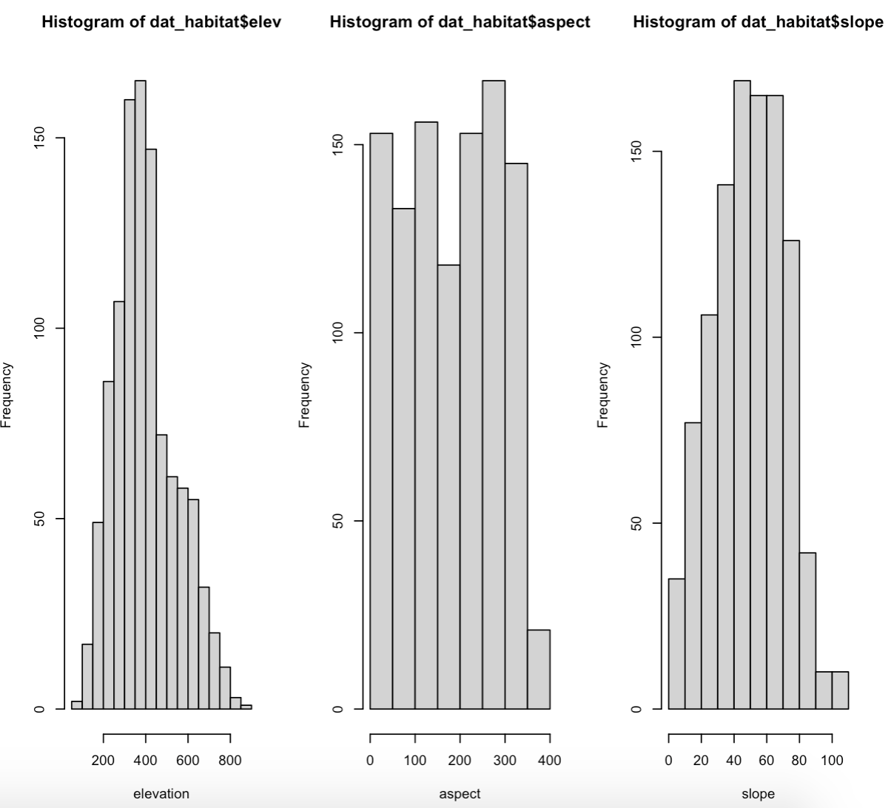

**Q2 Elevation Histogram Interpretation**

There is no even distribution of sampling site elevation since the plot is slightly skewed to the right. If there would be an even distributed the plot would be bell shaped. There are more low-elevation than high-elevation sites with the highest number of elevation sites are around 400.

**Q3 Slope Units**

Steepness of habitat (mountain, hill) (in %)

**Q4 Slope Histogram Interpretation**

It is almost evenly distributed with a slight skew to the right, meaning that there is an almost even mixture of steep and shallow sample sites but less many sites steeper than 60. The steepness of most sites is around 40.

**Q5 Briefly define aspect, describing the units used in this dataset.**

Aspect is the geographical compass direction that a slope faces, measured in degrees. (Make assumptions on sun exposure)

* North (N): 0° = 360°
* East (E): 90°
* South (S): 180°
* West (W): 270°

**Q6 Aspect Histogram Interpretation**

The plot is uniform, meaning that every value occurs roughly the same number of times. There are roughly the same amount of sample sites facing north, east, south, and west.

**Q7+8**

There is no noticeable association between the variables, since the data points are just randomly distributed and don’t show any pattern. That means the variables are independent from each other.

The linear model is not a good fit, since the data is randomly distributed.A line of best fit is a straight line that best represents the data on a scatter plot, and our line does not present the data well = no good fit.